**Burns Night(s) in Yellowknife**

**Scribe - Andy Harrower RBANA Canadian Director**

We sit approximately 400km south of the arctic circle in the capitol city of the Northwest Territories, Yellowknife. Enjoying warm summers and cold, long, dark winters, it was at -33 that our celebrations of Scotland’s favourite son took place this year.

The Joint Task Force North (JTFN) Officers’ Mess held their ‘Nicht wi’ Burns’ on Friday 26 Jan. The 70 officers and guests sitting down to dinner, were later joined by the NWT Pipes and Drums and the Yellowknife Scottish Country Dancers (YSCD). Haggis for the evening was provided by Tom Carmichael of Marsh Lake, Yukon, and the now famous ‘Haggis Truffles’ were flown in from Edinburgh, arriving only 3 hours prior to the event (well done FEDEX)!

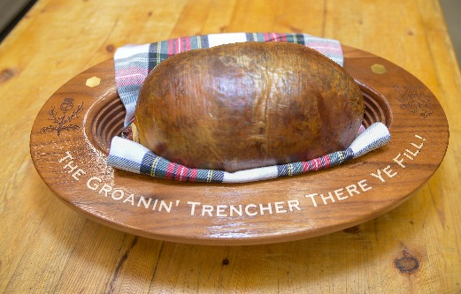

The gathering enjoyed a night of joviality, capably manged by the MC for the evening, Conrad Schubert. Mark White gave the Toast to the Lassies, with Mel Parker giving a brief response. I kept myself busy with the address to the haggis, in addition to ensuring the Atholl Brose was plentiful and flowing.

A powerful rendition of Scot’s wa’ Hae was delivered by Jeremy MacDonald, accompanied by Angela McDonell on the pipes. Angela also gave a great performance with the other members of the pipes and drums that joined us for coffee and shortie later in the evening. Thier bagpipe lessons for the seven willing volunteers were particularly well received by the audience.

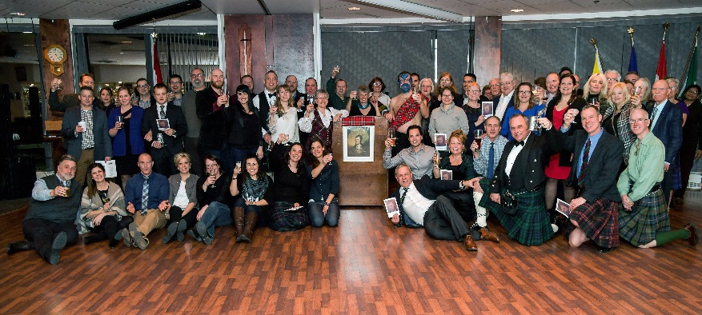Based upon the popularity of the dancing last year, the YSCD were invited back and yet again, you couldn’t keep us, or them, off the floor! A rousing chorus of Auld Lang Syne was enjoyed before bringing the evening to a close – although many stayed for some impromptu performances as we finished off the Atholl Brose. A great time was had by all, with many of the first-time Burnsians of this year already planning for the 25th in 2019.

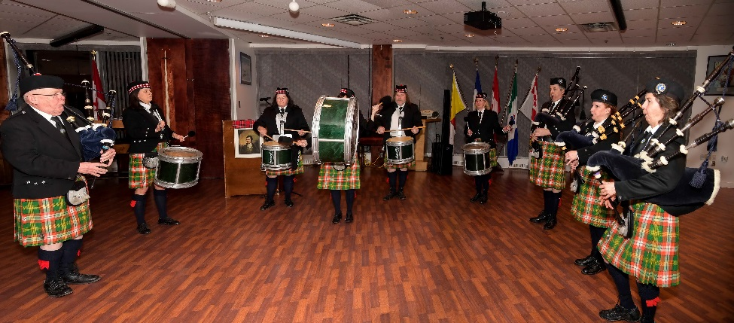

Straight from their final ‘dress-rehearsal’ at the Officers’ Mess, the NWT Pipe Band held their own Robert Burns Supper in The Top Knight on Sat 27 Jan.

This event was attended by 130 Yellow-knifers, all of whom enjoyed a packed entertainment program of home grown artistes. The evening included dancing demonstrations from the very youthful ‘Chilly Ghillies’, two sets of stirring music from The Aurora Fiddle Society’s very own Fiddle Cats and individual singing performances from Grace Clark and 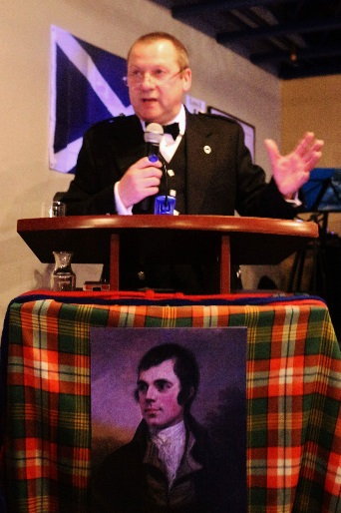Taylor Soloy. Yours truly gave the Immortal memory, my second of the weekend, and Conrad stepped up to the mark again with his address to the haggis.

It was coincidence that the YSCD were having a dance workshop that very weekend and so they were also in attendance, in force, including the visiting instructor, Sharon Barker from Calgary. Conversations later revealed that Sharon is the daughter of Calgary Burns Clubs very own Jim Osborne – it’s a small world eh!

Dancing until the wee sma’ oors was then called for, followed by a brief reflection on a fantastic weekend, involving many youthful newcomers. The old faces were all there too, but it was nice to see that the next generation are keen to follow in the footsteps of those that celebrate Scotland’s favourite son. Slange