**THE BURNS CLUB OF VANCOUVER**

**2019 Annual Burns Supper**

The thirty first Annual Burns Supper of the Burns Club of Vancouver was held in the Westerleigh in West Vancouver on Friday January 18th, 2019. 38 members and guests were piped into dinner by piper Tom Merry. President Donald Paton was in the chair and acted as Master of Ceremonies.

Bob Black said the Selkirk Grace and Eric Sanderson gave the Loyal Toast, following which our singer, Tristan Chalcraft, led us in singing the national anthem. Piper Tom Merry piped in the haggis, Chef Alan bearing the platter with escorts and sword bearers Bob Black and Bob Dyer. The haggis was addressed by Donald Paton. Dinner included Cock-a-Leekie soup and an excellent beef tenderloin to go with the haggis, followed by trifle, and after dinner, piper Tom Merry played a medley of pipe tunes and Tristan Chalcraft sang a number of Burns’ songs.

The toast to the Immortal Memory was proposed by our Club Treasurer, Dave Mackie, who gave an outstanding address.

The toast to “The Lassies” was proposed by Norman Thomson, who explained h is own love for the fair sex. Alastair Taylor gave the toast to “The Twa Lands”, recalling the number of Scots who were involved in the early development of Canada. Donald Paton then recited “Tam O’ Shanter”, adding to the drama with a darkened room, a candle and clothing props. The evening ended with the singing of “Auld Lang Syne”.

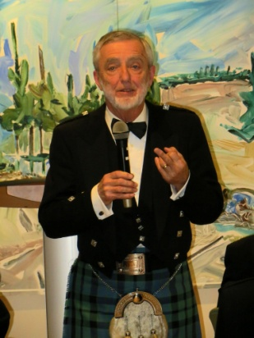 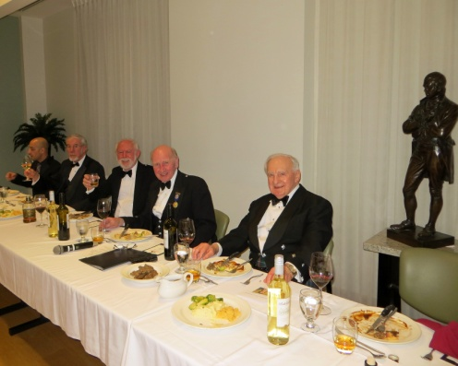

Dave Mackie gives The Head Table

The Immortal Memory

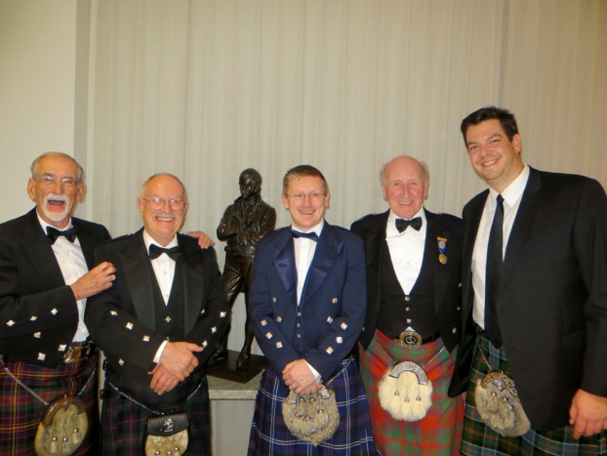

Guests , with Burns’ statue