THE BURNS CLUB OF VANCOUVER

2018 Annual Burns Supper

The thirtieth Annul Burns Supper of the Burns Club of Vancouver was held in the Westerleigh in West Vancouver on Friday January 26th, 2018. 32 members and guests were piped into dinner by piper Tom Merry. President Donald Paton was in the chair and acted as Master of Ceremonies.

Bob Black said the Selkirk Grace and Norman Thomson gave the Loyal Toast, following which our singer, Tristan Chalcraft, led us in singing the national anthem. Piper Tom Merry piped in the haggis, Chef Alan bearing the platter with escorts and sword bearers Bob Black and Bob Dyer. The haggis was addressed by Donald Paton. After dinner, piper Tom Merry played a medley of pipe tunes and Tristan Chalcraft sang a number of Burns’ songs.

The toast to the Immortal Memory was proposed by Alistair Taylor, a former member of our Club. He took as his theme Burns’ place in history as depicted by his various biographers, and by the writings of contemporaries and subsequent admirers, ending by quoting some stanzas from the poem about Burns written by Longfellow in which he expresses his admiration.

The toast to “The Lassies” was proposed by Eric Sanderson, and David Mackie gave the toast to “The Twa Lands”. Donald Paton then recited “Tam O’ Shanter” in his inimitable style. The evening ended with the singing of “Auld Lang Syne”.

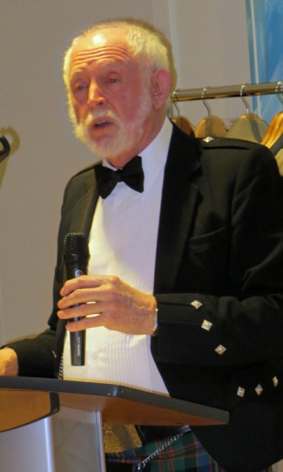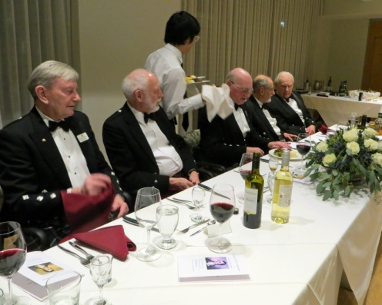

Alistair Taylor gives The Head Table
The Immortal Memory

