The Robert Burns Club of Milwaukee, founded in 1986, held its annual Burns Supper at our usual watering hole, Klemmers Williamsburg Inn in West Allis, Wisconsin, on Sunday, February 11, 2018. The city had been plagued by snow during the past week and many places closed on the previous Friday. But our intrepid dinner patrons trudged through the frozen tundra to enjoy Robert Burns, haggis, dancing, and sangs and clatter.
Wisconsin is known for its happy cows, and fish‐filled lakes and rivers, so diners had a choice of whiskey marinated sirloin or Cod Almandine (although vegetarian and medical diets are accommodated). And barley soup, haggis (of course), tatties and neeps (of course), and shortbread and chocolates for dessert.
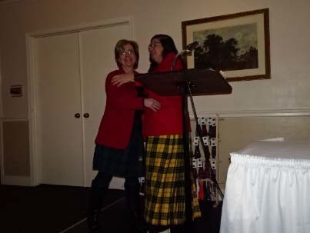
President Priscilla Kucik blundered in the President's Address, welcoming "ladies and gentlemen‐‐and the rest of you" and then stopped in horror at her un‐Burnsian solecism addressing people by social status. So, she started again with "Lassies and Laddies", noting the humanity in the world of Robert Burns made everyone equal. Then, admitting that her mind was so clean because it was changed so often‐‐she declared that one person was better than us all and dedicated the evening as Wendy
Wilson Uhl Appreciation Night, honoring a founder and charter member of the club who has been the worker bee behind the scenes. People were encouraged to kneel and kiss her hand, strew rose petals in her path, or, just say "Hello".
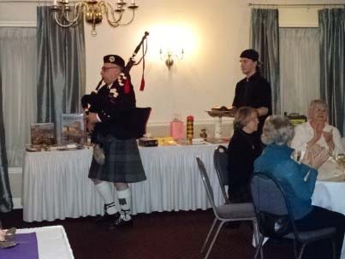
The Selkirk Grace, led by Wendy Wilson Uhl, started the Burns Supper. Tony Palese piped in the haggis.

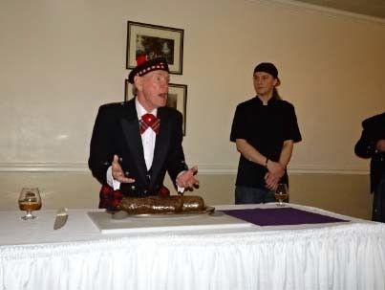
Vice President Ian Day performed his signature dramatic rendition of Burns' "Address to a Haggis",with flying knife blades and a resounding "bethanket hums" belch.

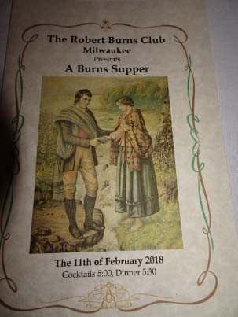
The colorful, exceptionally beautiful program was designed by Janet Kerr Carroll, daughter of the club's founder, William Kerr. She is a published Burnsian and emergency medical technician (although she does not work in the Burns Unit).

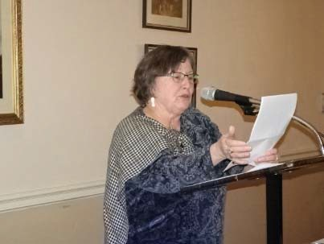
The Toast to the Immortal Memory was given by Linda Daly, noting Robert Burns' concern for the Common Man (and especially, Woman) at the mercy of the Great Ones still resonates today. Many of Burns' political concerns are still relevant.

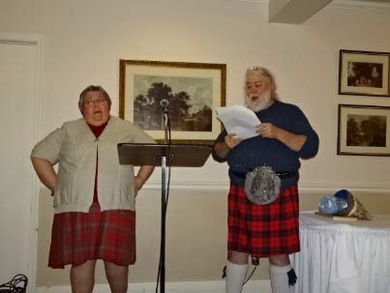
Russell Read sang (literally) the "Toast to the Lassies", to the tune of "The Parting Glass" ("Sae gie tae me the pleasant cup/ That nae sma' drink I maun offer up") and his guidwife Jessie Read sang " The Lassies' Reply" , "Ae fond kiss, and then we shiver/Aye sweet glint, and then deliver"),

A popular raffle highlights the Milwaukee Burns Suppers and has made it it possible to hold the ticket price steady for $25 for almost 20 years. Like the thrifty (by necessity) Robert Burns, we too "suffer the supreme curse of making 3 guineas do the work of 5". Raffle items included the usual books and bottles but also featured jumper cables, gift certificates, and Scottish antique dishware and vintage postcards.
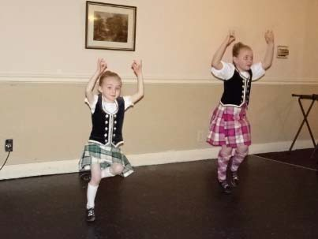
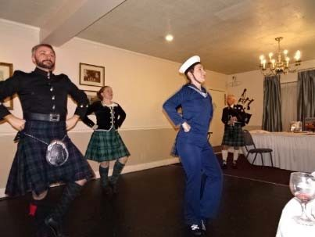
The Caledonian Scottish Dancers gave an educational introduction to each Scottish dance before performing it. The renovation of Klemmer's included the removal of the middle chandelier that has plagued the taller dancers in previous years and tonight they
danced with a renewed sense of security .
Tony Palese piped. Then, "the night drave on wi' sangs an clatter".
The evening reluctantly ended with a circular singing "Auld Lang Syne", with Wendy Wilson Uhl in the middle, as "she has run circles around us; now we return the favor."
Guests, laden with fond memories, satisfied palates, and treasured raffle prizes, went out "roamin'in the gloamin' " until next year.

