For those who don’t know, the Medicine Hat Burns Club established the Jolly Beggars Banquet as a special event for Burn's keeners, prospective new members and those deemed worthy. Over the years interest in this event has grown and where attendance is limited to 37, as Burns was 37 when he died, the Club is getting expressions of interest of upwards of 50 to 60 men to attend each annual event. This makes guest selection very difficult, however that being said the Club has made a firm commitment that this event remains open to only 37. Also, this event is black tie, kilt or trews. Cronies attending do not wear uniforms, medals or decorations other than Burns Club or related insignia.
So, well, the Medicine Hat gang did it again. The 2017 9th Annual Jolly Beggars Banquet in Medicine Hat is now being reported as being probably the best Jolly Beggars Banquet held to date. With respect to entertainment the Commander of the local British army training unit (BATUS) authorized the attendance of a quartet from the Band of the Corps of Royal Engineers that were temporarily here from the UK. What a coup!.
The Calgary Burns Club singers were also present who proudly gave their all and sang and danced unto the wee hours. Further, there was Club piper Malcolm Sissons, who was later matched up with Club Gaird & Chaplain, Rab Cowan, also a piper who also brought his pipes.
Next, we had Club VP and RBANA Canada director Andy Harrower performing A Mans a Man and later, Tam o’ Shanter. Club president Bill Cocks did his thing and presented the Address to the Haggis. A most memorable rendition of ‘To a Mouse’ was done by Andy Cowan, and then there was the meal. Starting with salmon with cream cheese, capers and onions, this was followed by cock o’ leeky soup, then stacked haggis prepared by a chef from the British army. Next, rack o’ lamb with a special mint sauce followed by a unique Scottish pie for desert. Dinner was then finished with home made Athol Brose.
The Jolly Beggars world famous Scotch bar also offered some very fine Scotch whiskies and the Immortal Memory done by our Chieftain o’ the Nicht and RBWF President, Ian McIntyre was outstanding.
The only dilemma is that next year will be very special, as it will be the 10th anniversary of the Jolly Beggars Banquet, and it will be a real challenge to make that event better. That being said there shall be no doubt the Medicine Hat Burns Club will pull it off.
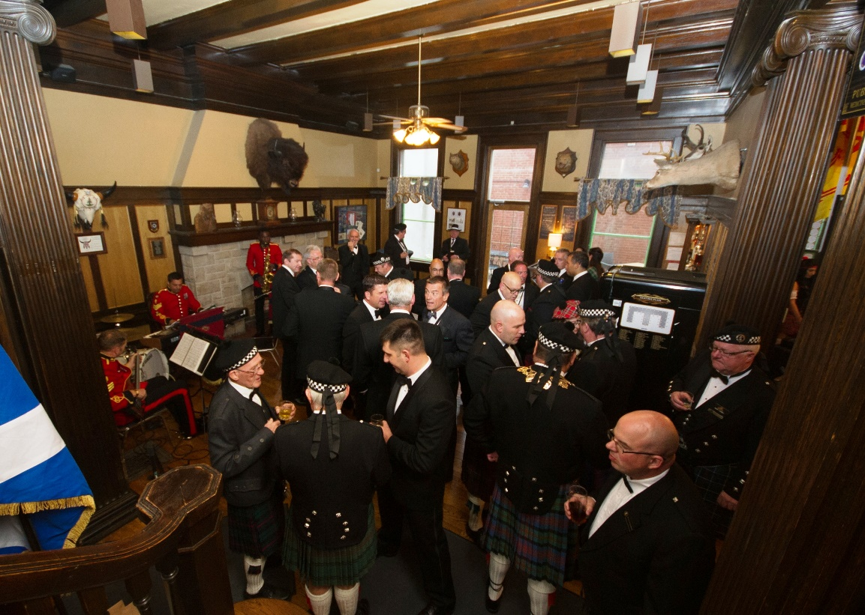
Cocktail hour at the Cypress Club
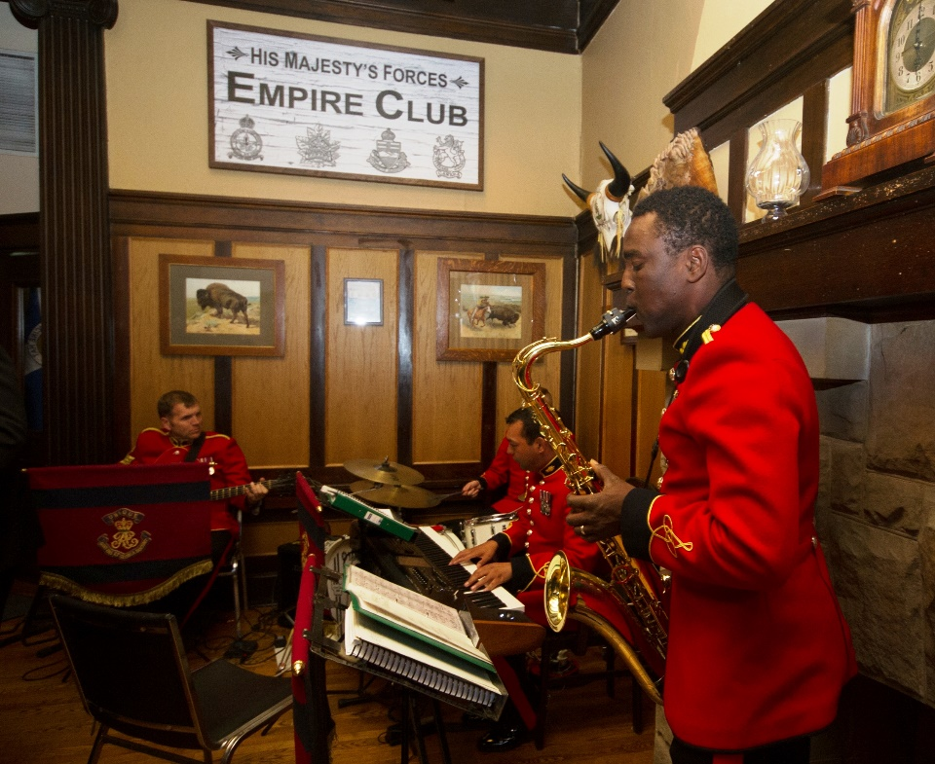
Quartet from the Band of the Corps of the Royal Engineers entertain the attending cronies.
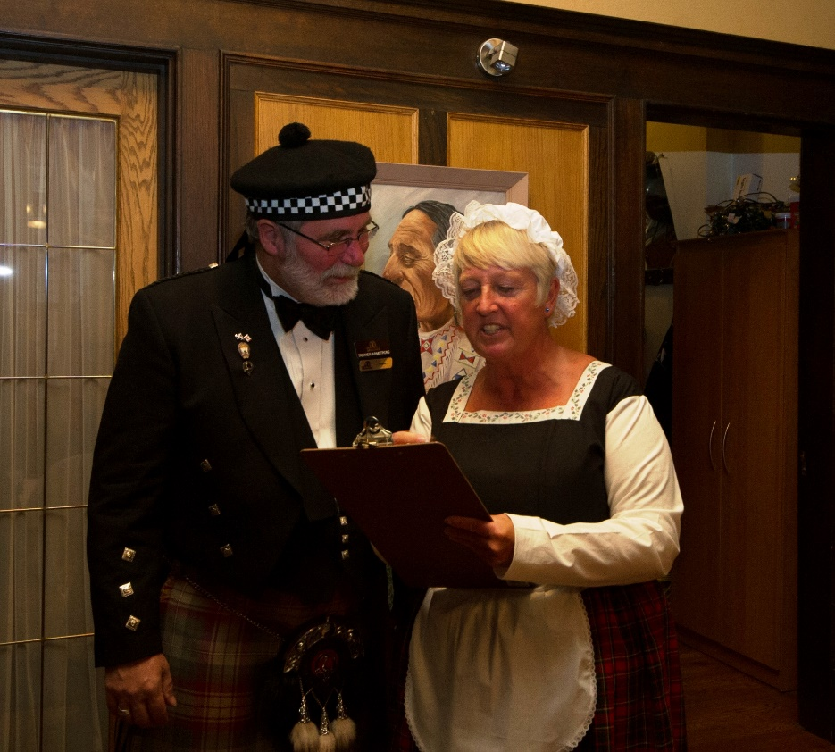
Poosie Nancy checks in the cronies as they arrive, and let them know who’s boss. This years Poosie Nancy was Debbie Wilde, formerly travelling globe with the Woman’s Royal Army Corps., Debbie, originally from Reading, Berkshire, England now serves at BATUS with Services Welfare.
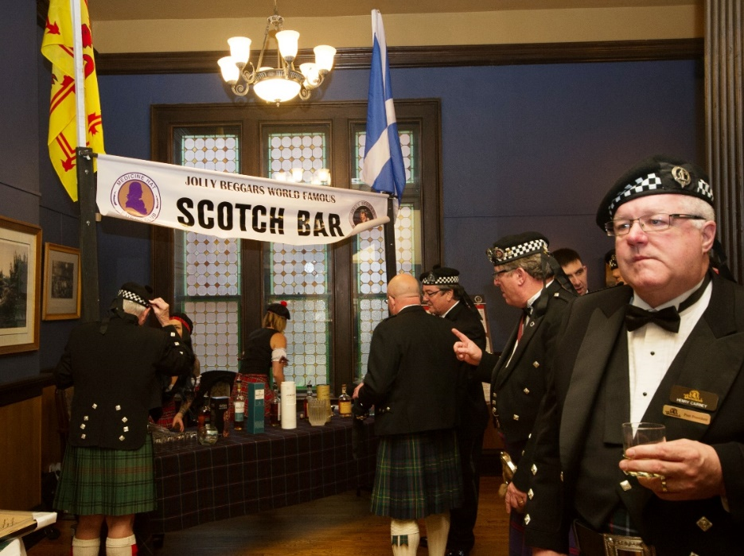
The cronies line up at the world famous scotch bar and sample some of the finest Scotch whiskies available.
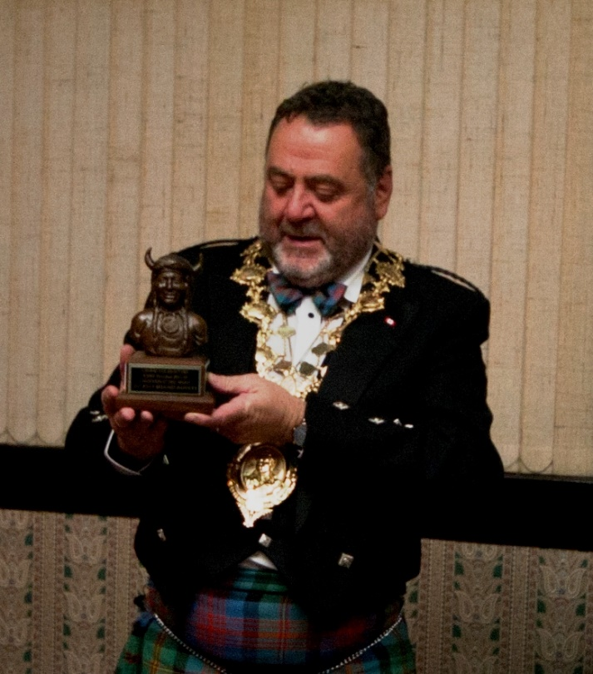
Chieftain o’ the Nicht, and RBWF President Ian McIntyre is presented with a special Western Canadian token as a memento of the attending Cronies respect, esteem and appreciation for his participation and for presenting the Immortal Memory.
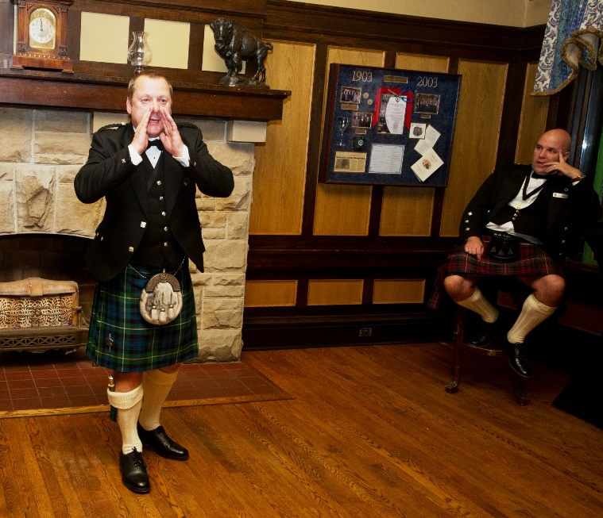
After dinner the Cronies move into a full Ceilidh and here, with Edmonton Burns Club president cam McDonnell watching on, Club VP, and RBANA Canada director Andy Harrower does his rendition of ‘Tam o’ Shanter’.
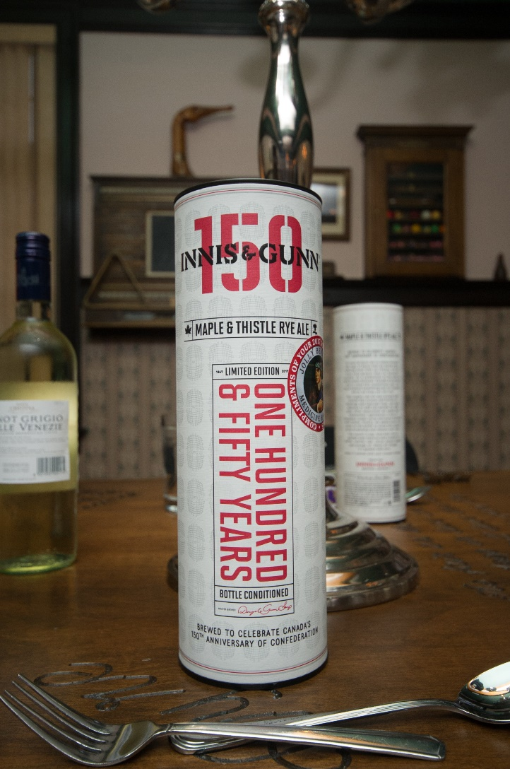
As a special treat, and as 2017 was Canada’s 150th anniversary of Confederation, each Cronie attending was given a special commemorative edition of Innis & Gunn’s Maple & Thistle rye ale. Matured in 150 oak barrels for 150 days , and made to celebrate the 150th anniversary, this special treat was difficult to acquire in the amount required but it was done.
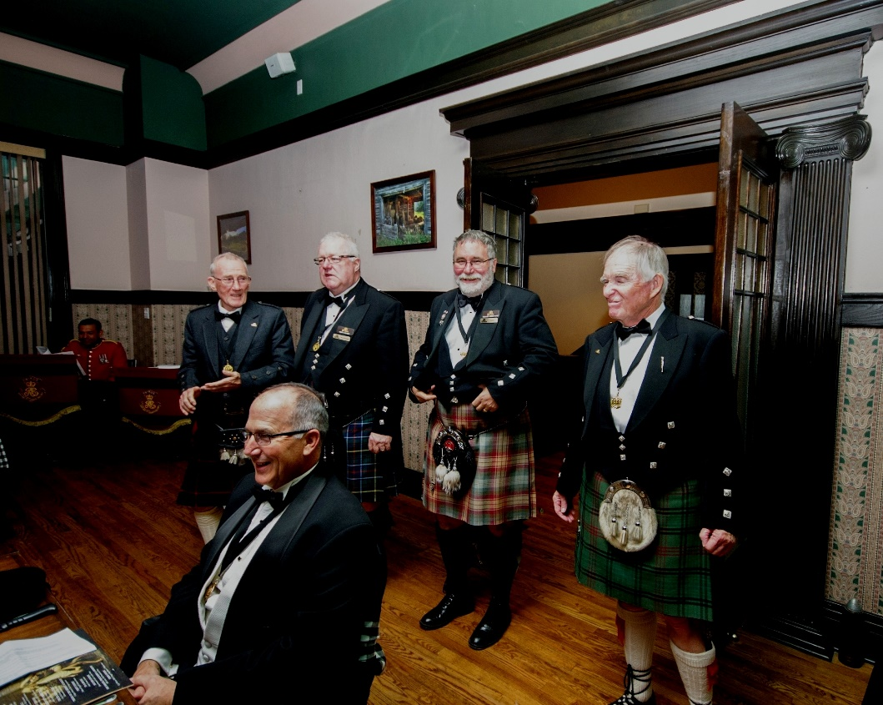
Calgary Burns Club singers, Ron Pratt, Henry Cairney, also a RBANA Director, Canada, Trekker Armstrong and Jim Hope-Ross entertain the gathering.
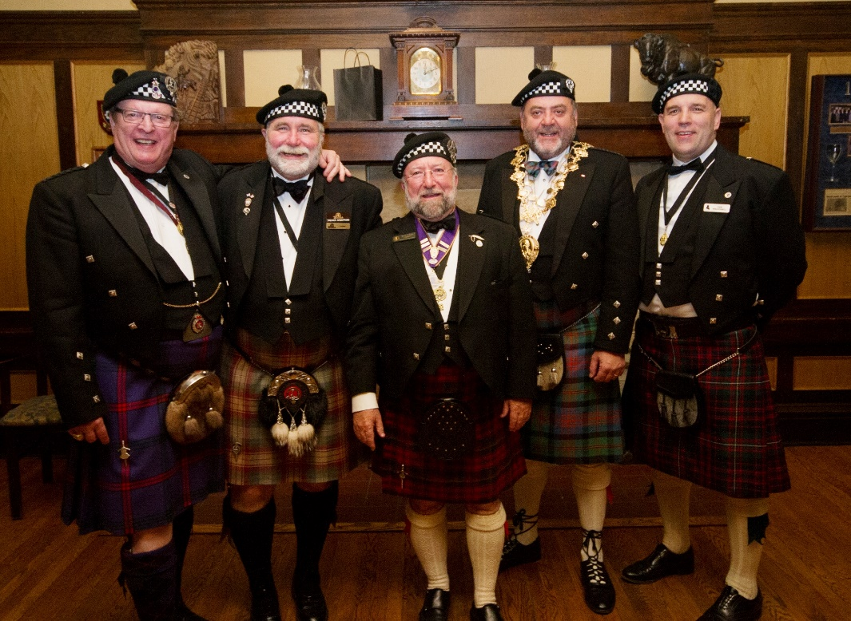
Gathering of the presidents. Left to right, Ken Montgomery, VP, RBANA, Trekker Armstrong, Calgary Burns Club president, Bill Cocks, Medicine Hat Burns Club president, Ian McIntyre, RBWF president and Cam McDonnell, Edmonton Burns Club president.
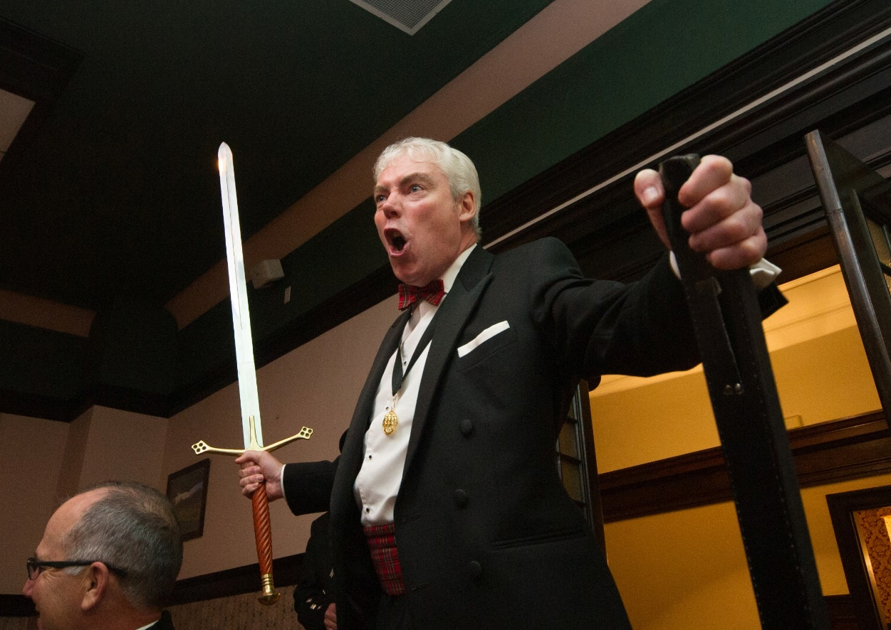
Kenny McMillan completely grabs the attention of all Cronies present, food staff, car staff and anyone within earshot, with his mesmerizing and stimulating rendition of Scots Wha Hae, compete with swinging broadsword.
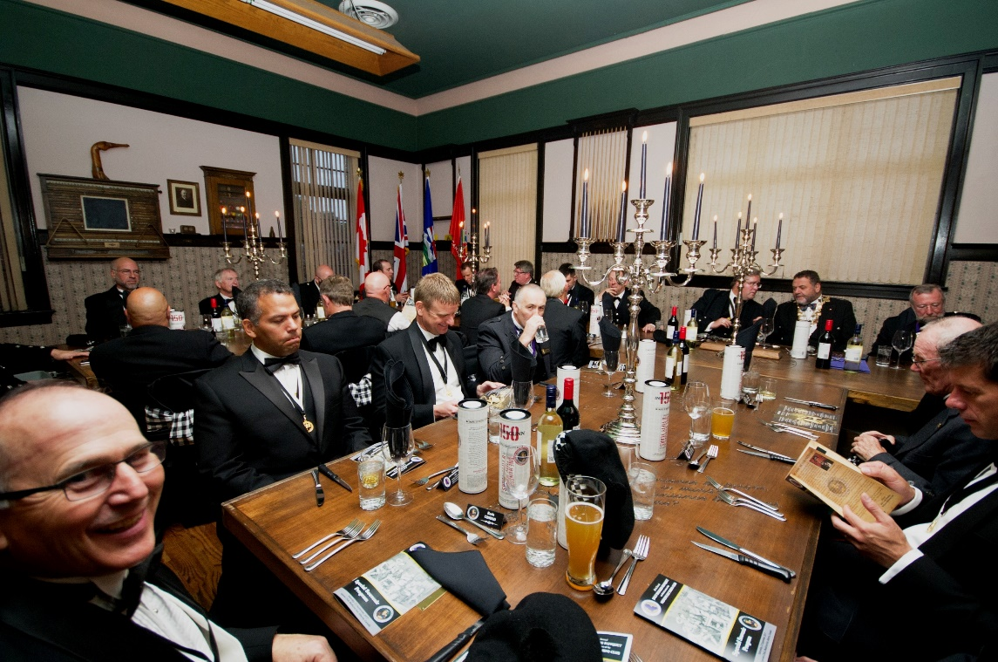
The cronies prepare to dine. For those attending for the first time, there is considerable anticipation.
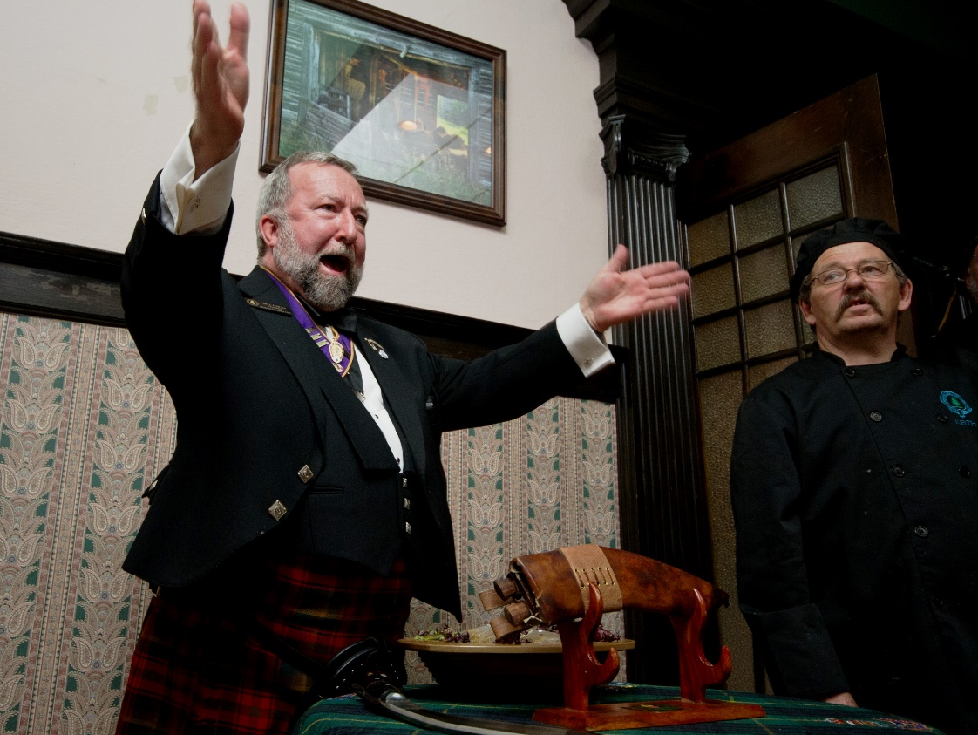
Medicine hat Burns Club president Bill Cocks, addresses the Haggis.
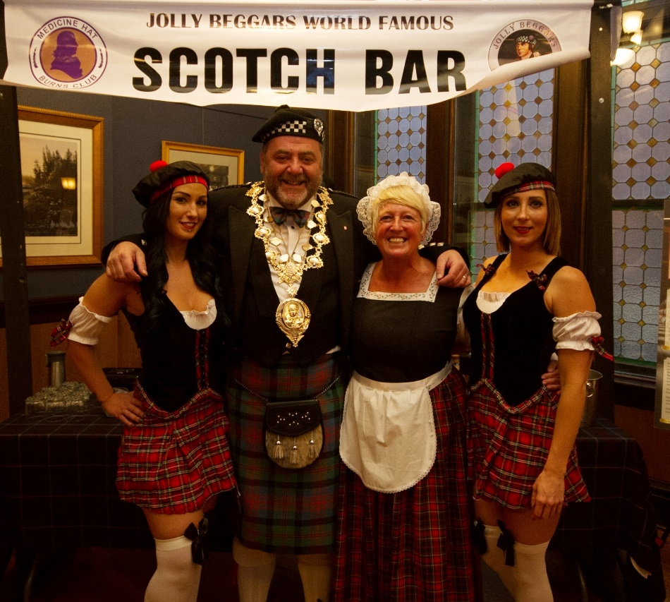
RBWF President Ian McIntyre congratulates the Scotch Bar Lassies and Poosie Nancy on doing an outstanding job.
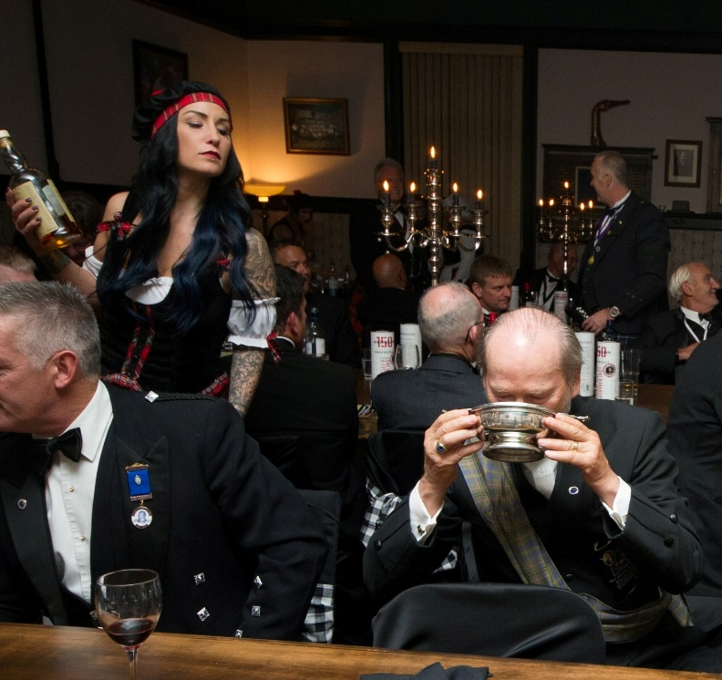
Prior to closing the dinner part of the program, and finishing with Auld Lang Syne, supervised by Kristina Shoesmith, Scotch Bar manager, the full sized Quaich is passed Cronie to Cronie so those attending can formally morph into one collective being. Seems to work as it is a recognized tradition of the dinner.
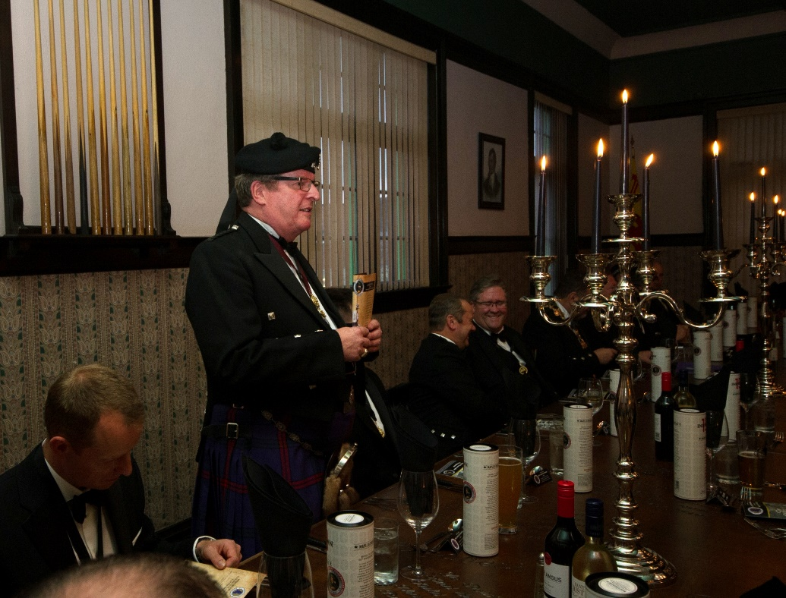
Ken Montgomery, RBANA VP and secretary of the Medicine Hat Burns Club gives an official greeting on behalf of RBANA before calling the Cronies roll call.
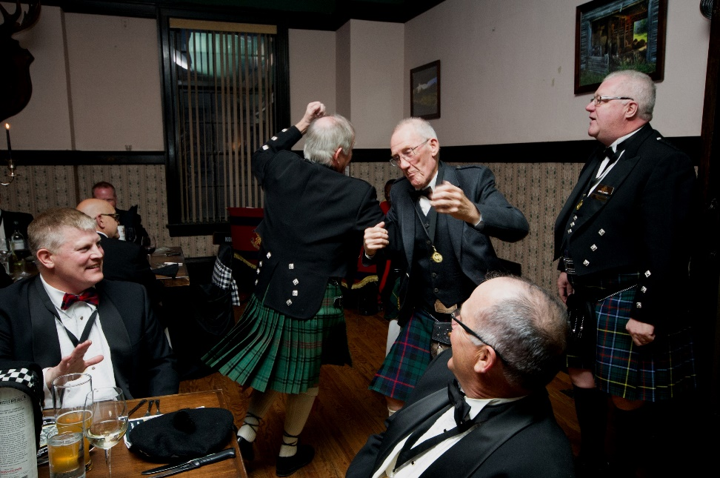
The Calgary Burns Club singers get the Cronies rockin...................

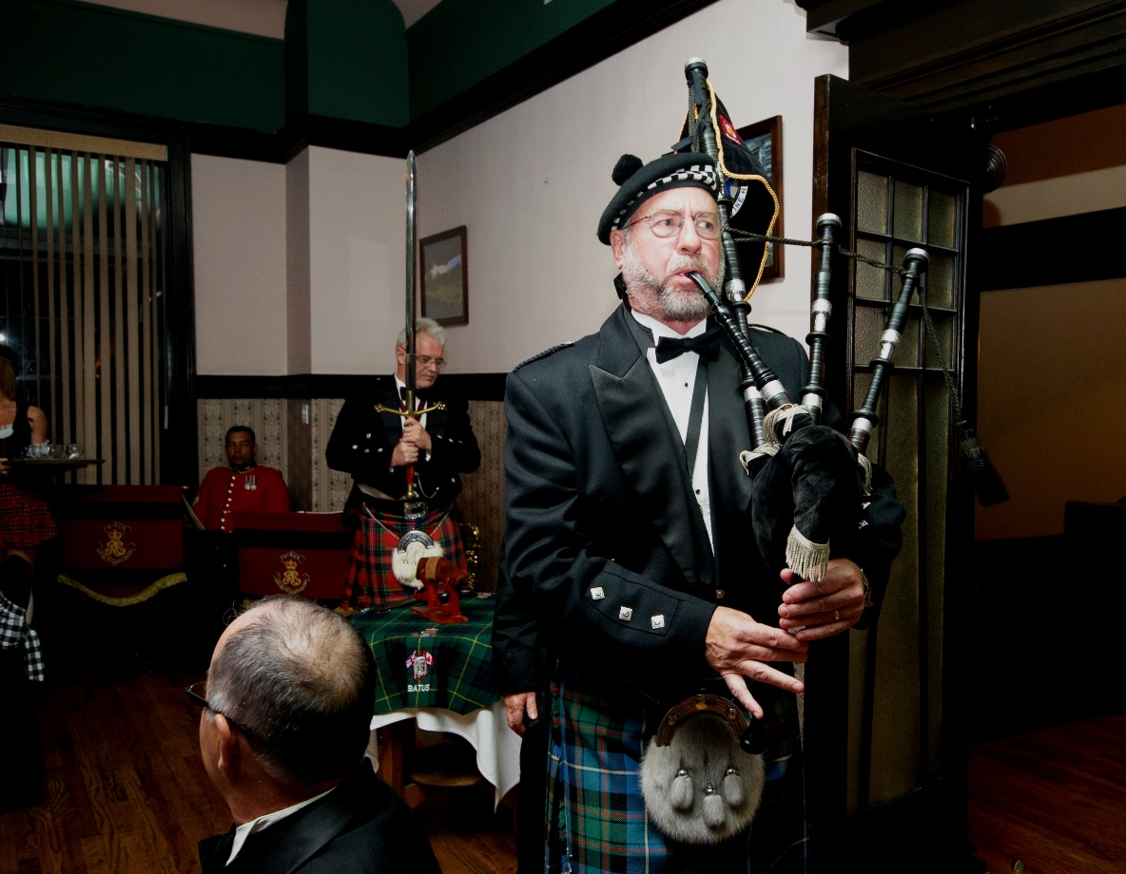
Club Piper Malcolm Sissons escorts the haggis with Club Gaird & Chaplain backing him up with the claymore

