Lethbridge Robert Burns Society
47th Annual Supper
Lethbridge, Alberta – January 27th, 2018
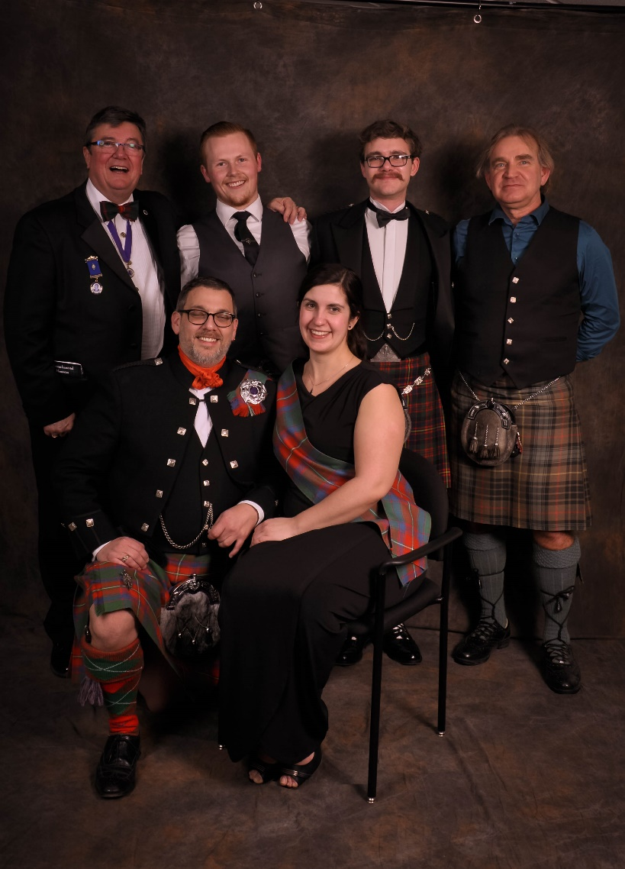
Some of the 2018 Organizing Committee
Front Row: Steve Firth (President); Taryn Rodzinyak (Secretary);
Back Row: Mike Duffy; Chris Lowen; Grayson Taylor, David Kaminski (Piper)
Missing: Laurie Kaminski; John & Myrna McMillan

For the first time in many, many years, the Lethbridge Robert Burns Society organized and ran the Annual Robert Burns Dinner outside of the Royal Canadian Legion in a larger venue. The 2018 Dinner was held in the Lethbridge Multicultural Centre and hosted 166 loyal Burns fans.

President Steve Firth, pulled triple duty as the Chief Organizer, Scotch Bar Manager (providing us with a hearty selection of Single Malt Whiskies), and Master of Ceremonies for the evening. Surprisingly, he was not Burnsed-out by it all.
Secretary Taryn Rodzinyak kept us all on track, including President Steve’s exuberance.

John & Myrna McMillan arranged for the Lethbridge Highland Dancers to open the evening demonstrating many traditional Scottish dances.

Piper David Kaminski led the Royal Canadian Legion Pipe Band in a wonderful presentation of Highland music which was thoroughly enjoyed by all.

Piper David also arranged for the Band – Cabot’s Crossing who played for a Dance later in the evening.

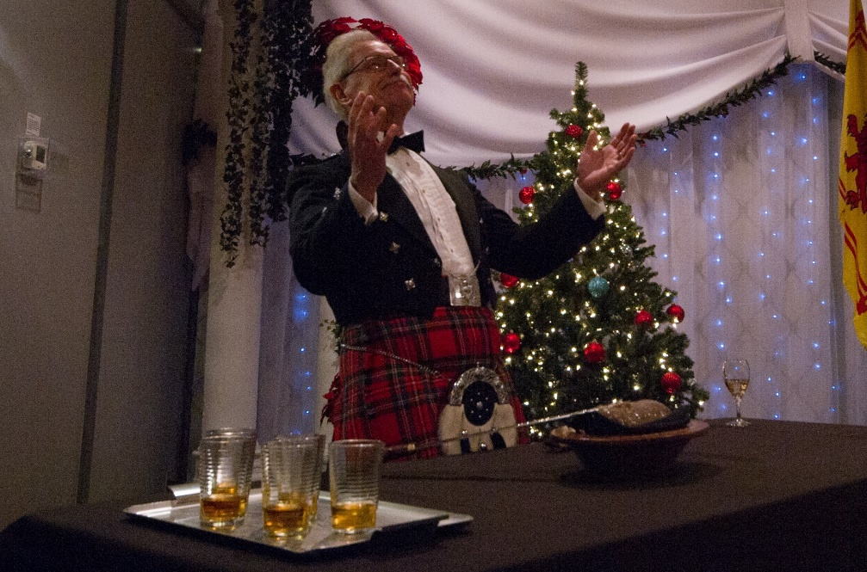
The incomparable Bill Halley delivers the Address to the Haggis
- and gives praise to the lovingly eviscerated Beastie

The evening was full of traditional Burns Dinner fare and some surprises: Songs of Scotland sung by Juran Greene & accompanied by Juanita Asselman; the Toast to Scotland by John Black; the Toast to Canada by Shannon Phillips, MLA & Alberta Environment Minister; the Immortal Memory by Jay Gamble; a Toast to Lassies by Mark Campbell; the Reply to the Toast to Lassies by Fiona Miller and the late, great Glaswegian Matt McGinn’s tale of the Big Effen Bee by Mike Duffy. Mark Campbell, having moved on from broadcasting and now a Lethbridge City Counsellor, had the crowd roaring and was a difficulty act to follow.

Jolly Beggar Ron McDonald, QC, and long-time supporter of the Lethbridge Robert Burns Society, provided the dangerously drinkable Atholl Brose.

Marla Fern Photography (mfphotography@shaw.ca) took many candid and formal photographs for those attending.

