HALTON/PEEL BURNS CLUB
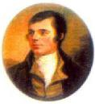
“for love of the Bard“
Member of RBANA & #2008 World Federation of Burns Clubs
Report on the service of Commemoration at the Burns Cairn
in Gore Park Hamilton Ontario on Sunday 23rd July 2017
The Burns Cairn was erected in 1984 by theYe Bonny Doon Burns Club which unfortunately disbanded in 1997 due to failing health and aging of the members.
The Rev E. R. Francis Chisholm DD {now 93} each year in late July has held a service of remembrance on the anniversary of Burns Death, usually attended by former Bonny Doon club members.
This year they invited the Halton/Peel Club to join with them and 7 of our members were able to attend.
The worship service was led by Rev.Francis Chisholm and the Burns’ appreciation was offered by Duncan Beattie a former Member of the Canadian Parliament and a longtime member of the former Bonny Doon Club.
What was special this year was the presence of the President’s chain of office from the Bonny Doon Club.
Chrys Ballantyne VP of Halton/Peel Club sported the chain, now to be used as the Vice President’s chain of office. There is a remarkable story about the chain.
About 5 years ago a cleaner at a local retirement residence noticed a small case in a dumpster there.
She recovered it and on seeing the Scottish symbols, asked another employee with a Scots name, McDonald, if she could perhaps help locate an appropriate party who would know what to do with it.
The young lady passed the Chain on to her father, a mason, and descendant of one of the early Highlander settlers in Prince Edward Island. He asked around but got no leads for a long time until one of his friends had occasion to mention it to a retired minister, Rev Bob Docherty, in Grimsby Ontario. Bob happens to be a member of the Halton/Peel club.
He referred him to Ron Ballantyne, the club secretary who was contacted by Mr. McDonald.
When Ron collected the chain and realized its significance he contacted Duncan Beattie, a former member of the Bonny Doon Club, and asked “what was the appropriate way to deal with it”.
Duncan with the approval of other former Bonny Doon members asked the Halton/Peel club to keep the chain and use it as deemed appropriate. We therefor plan to keep it as the Vice President’s chain of office.
It is surmised that the last President of the Bonny Doon club had retained the chain. She for some years has suffered from Alzheimer’s disease and possibly someone helping her clean out some possessions in the residence did not appreciate the significance of the chain and so disposed of it.
The Halton/Peel club had also recently been presented with the President’s chain of office from the former Galt Ontario Burns Club which ceased to meet about 20 years ago.
The Halton/Peel club had that chain refurbished, and are now using it as their Presidents Chain of Office.
In the accompanying photographs President, Jim Steel, wears the former Galt club chain and Vice President, Chrys Ballantyne, the former Bonny Doon Club chain.
There is a strong Scots connection with Galt. The town was founded by the entrepreneur and author John Galt, who is buried in the Greenock cemetery, recently the subject of an appeal for refurbishment by the Greenock Burns Club.

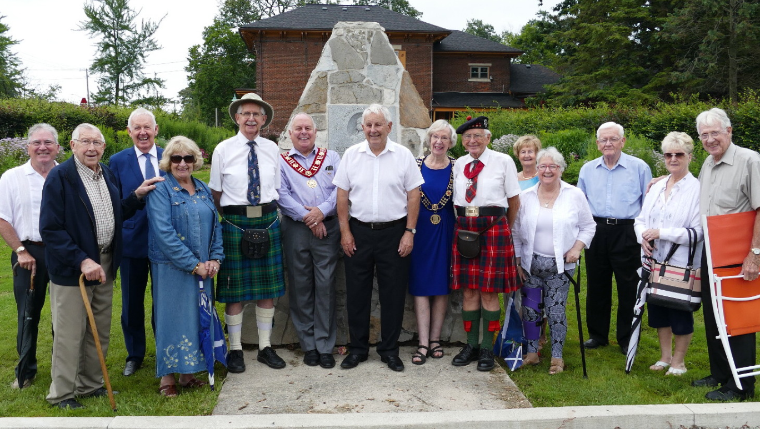
The gathering at the Cairn
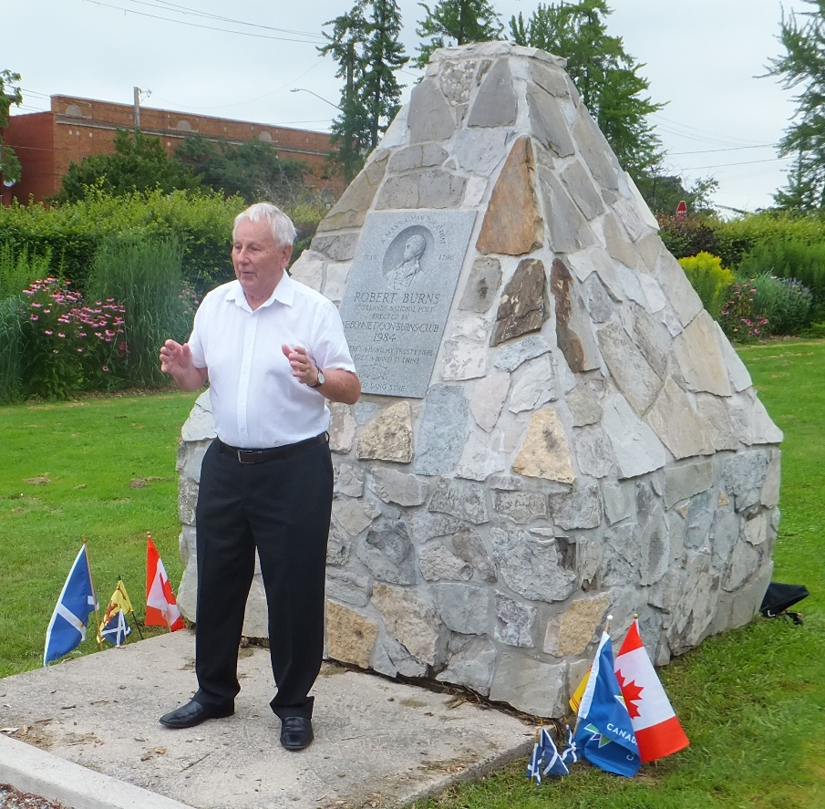
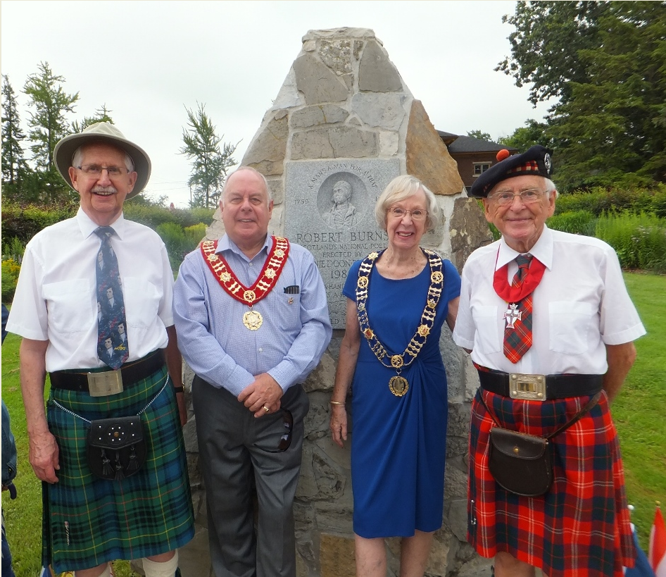

Ron & Chrys Ballantyne, Jim Steel, Duncan Beattie
with Rev Francis Chisholm
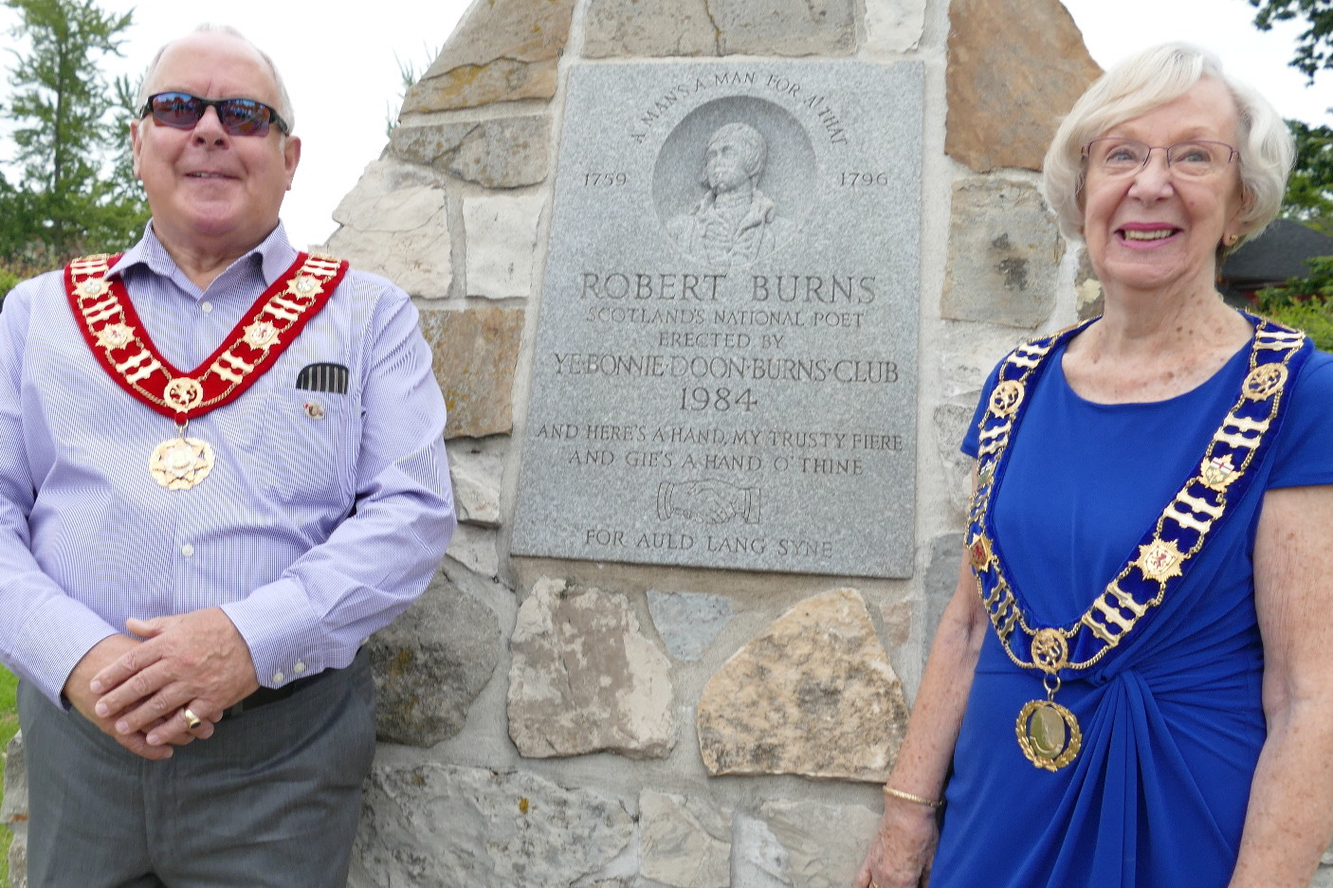

Jim Steel and Chrys Ballantyne and the Cairn.

