Once again we chose to celebrate the Bard on our meeting night closest to St Andrew’s day combining it with our usual Ceilidh.
We again held the event in the Holiday Inn Burlington where we had successfully done so for the previous 2 years. The November gathering suits those who are either committed to other Burns Suppers or spend the winter months in Florida.
This year we returned to our Members only format which allowed for more room for everyone.
Unfortunately Our President Jim Steel, Lindsay Steel and GraceAnn had to cancel, as Jim’s sister in Scotland had passed away suddenly. Vice President Chrys Ballantyne stepped in for Jim.
Jim Cunningham as M.C. ensured the proceedings flowed smoothly and the hotel staff were most efficient and accommodating.
The proceedings opened with the usual address to the haggis ably performed by Alan McKenzie.
Following the meeting one of our newer members, Jim Smith, delivered a fine Immortal Memory.
After the usual toasts, interspersed by musical interludes from Piper Bob Ritchie and traditional Scottish airs on the fiddle by Pierre Arnold and a friend, we broke for a short time.
The company then relaxed into the St Andrew’s Ceilidh with humorous presentations from members and more musical interludes. The evening passed quickly and we were at 11PM before we knew it.
The evening was pronounced a great success by all.
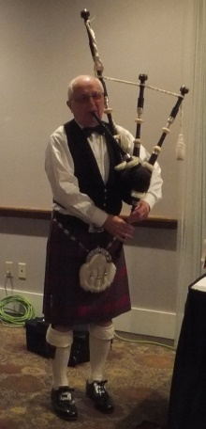
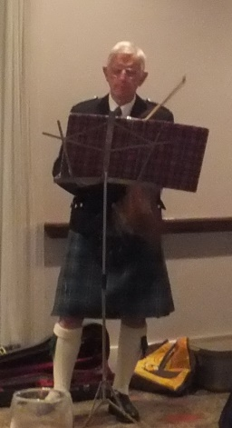
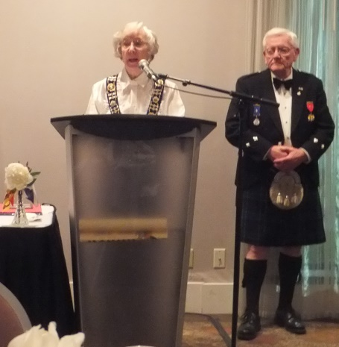
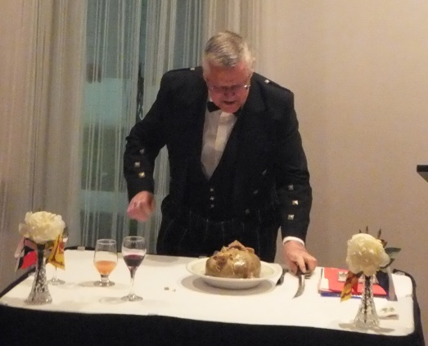
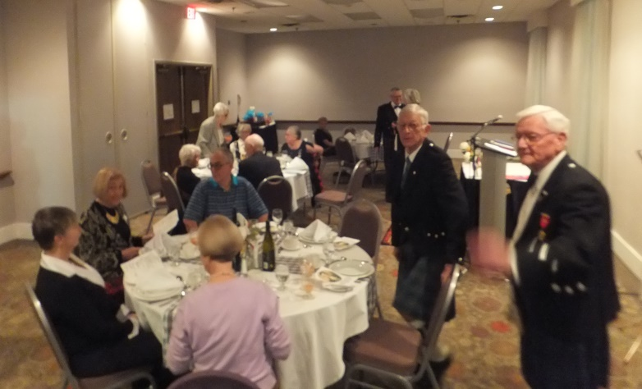
The gathering Welcoming: VP Chrys with M.C. Jim

Alan Addresses the Haggis Our Piper Bob Our Fiddler Pierre

